Lehigh County Arbitration
Practices and Procedures

Lehigh County Bar Association
March 6, 2024
12:15 p.m. – 1:15 p.m.

Panelists:
Thomas M. Caffrey, J.
Jeffrey Greenwald, Esq.
David Schattenstein, Esq.
Paige White

Table of Contents
SUBSTANTIVE ISSUES

Lehigh County Arbitration Statistics from 2014 through 2023

Cases Subject to Compulsory Arbitration

Lehigh County Arbitration Rules

Guidelines for Arbitrators

Guidelines for Arbitrations

Serving on a Panel

APPENDIX

Online Docket Access

Lehigh County Rules of Civil Procedure

Application for Continuance

Arbitration Hearing Continuance Policy

Telephone or Zoom Participation Request (example e-mail attached)

Arbitration Award Form

Transfer Form

Applications for Arbitrators

LEHIGH COUNTY ARBITRATION PRACTICES AND PROCEDURES
Lehigh County Court Administration is pleased to present the Honorable Thomas M. Caffrey to lead an overview and discussion on Arbitration Practices and Procedures. Joined by panelists Jeffrey L. Greenwald, Esq., David C. Schattenstein Esq., Civil Operations Officer Paige B. White, and Arbitration Coordinator Leslie A. Rodriguez, Judge Caffrey will address the following topics:
- Arbitration statistics and trends for Lehigh County from 2017 through 2023;
- Types of cases subject to compulsory arbitration;
- Pennsylvania Rules of Civil Procedure and Lehigh County Rules of Civil Procedure governing arbitration;
- Resources and best practices for attorneys serving as arbitrators;
- Guidelines and expectations regarding arbitration hearings.
The Honorable Thomas M. Caffrey was elected Judge of the Court of Common Pleas of Lehigh County in January 2022. He graduated from Allentown Central Catholic High School, the Pennsylvania State University, and the Dickinson School of Law. Judge Caffrey served in Lehigh County in several capacities during his career. From 1992 to 1997, he conducted juvenile delinquency and dependency hearings as the Juvenile Master. From 1998 to 2004, he worked as a prosecutor in the District Attorney’s Office. From 2004 to 2006, he headed the Children and Youth Services Legal Unit. From 2006 to 2020, he represented the County in federal civil rights and employment litigation as an Assistant Solicitor, and in May 2020, he was elevated to the position of County Solicitor. He has served as Arbitration Supervisory Judge since January 2023.
Jeffrey L. Greenwald commenced his legal career as a staff attorney with Lehigh Valley Legal Services (LVLS, now North Penn Legal Services after receiving his Bachelor’s Degree from SUNY at Buffalo and Juris Doctorate from Northeastern University School of Law. He remained with LVLS for over a decade as a staff and managing attorney in its Easton office before entering into a solo practice in Allentown. He maintained a general practice, including government benefits, employment law as well as family and juvenile law and civil and commercial litigation. Over time, he concentrated his practice in the area of Social Security Disability, at both the administrative and federal court levels. He has served as an arbitrator since entering practice, initially in Northampton County and, since 1990, in Lehigh County. He remains an active permanent panel member and regularly serves as a substitute arbitrator when the situation arises. He enjoys having the opportunity to observe the wide variety of attorneys who come before the panels and to engage in the process with counsel and the public.
David C. Schattenstein holds a Bachelor’s Degree from Muhlenberg College and a Juris Doctorate from Temple University Beasley School of Law. He is on the Board of Directors of the Pennsylvania Creditors Bar Association, currently serving as the secretary. Attorney Schattenstein is a member of the Equipment Leasing Finance Association, International Association of Commercial Collectors and Commercial Collection Agencies of America. He is a life member of the American Bankruptcy Institute, having previously served as a bankruptcy trustee in the Eastern and Middle Districts of Pennsylvania. Attorney Schattenstein has been a frequent lecturer on office management and creditors’ rights and insolvency topics, having written several published articles. He became of counsel to Wiener and Wiener in 1999, followed by his affiliation as of counsel with Keifer Law Firm, LLC in 2013.
Paige White is a graduate of West Chester University, where she earned both a Bachelor’s Degree and a Master’s Degree in Criminal Justice. Having previously interned with Lehigh Valley Pretrial Services, Mrs. White worked in Lehigh County Family Court from 2015 through 2021. In 2021, she joined Court Administration as a Criminal Calendar Control Officer for the Honorable Douglas G. Reichley and the Honorable Robert L. Steinberg. Mrs. White currently serves as the Civil Operations Officer for Lehigh County.

LEHIGH COUNTY ARBITRATION STATISTICS FROM 2014 THROUGH 2023

CASES SUBJECT TO COMPULSORY ARBITRATION
Compulsory Arbitration - Scope
All civil actions which are subject to compulsory arbitration under the Judicial Code, in which the amount in controversy, exclusive of interest and costs, is Fifty Thousand ($50,000.00) Dollars or less, shall be submitted to compulsory arbitration.
The amount in controversy shall be the largest amount claimed in any single count of the pleadings by any party.
The court, upon the written motion of any party, or upon its own motion, may require that a case for which a trial is demanded be first submitted to compulsory arbitration pursuant to these rules.

Magisterial District Judge Appeals
All matters that are appeals from a district justice decision may be scheduled for an arbitration hearing sixty (60) days after the appeal is taken, unless there are outstanding pleadings, motions, petitions, or other matters that require court disposition. The parties to a district justice appeal shall file pleadings and complete discovery within sixty (60) days of the date of the appeal.

Real Property
Actions in ejectment, unless involving title to real property, are subject to compulsory arbitration.

LEHIGH COUNTY ARBITRATION RULES
Cases filed in which the amount in dispute is $50,000 or less and Magisterial District Judge appeals are submitted to compulsory arbitration. New case filings reported weekly are reviewed by the Civil Operations Officer. Early identification of arbitration cases provides for timely disposition of these matters. Arbitration cases are randomly assigned to one of the civil judges for monitoring of the case and handling of all motions and petitions.

Attorneys who wish to serve as an arbitrator must meet certain eligibility requirements. They must: be a member of the Bar of Lehigh County; have an office within Lehigh County, express a willingness to serve, and remain up-to-date on technology. Interested attorneys must submit their name to the Court Administrator. Assignment to a permanent panel is with the approval of the Arbitration Administrative Judge. Arbitrators are expected to complete their arbitration dates as scheduled – failure to serve on a panel within a year’s time may cause the arbitrator to be removed from serving.

The Arbitration Coordinator schedules cases for arbitration. Magisterial District Judge appeals are listed on the first available list 60 days after the appeal is taken. All other matters are listed for hearing no later than one year after the complaint is filed. All parties, including self-represented litigants, must follow all applicable Rules of Civil Procedure specifically pertaining to filing and service of the complaint.

A case may be scheduled for arbitration upon praecipe of any party. Counsel must serve the opposing side with a notice of intent to praecipe. If additional discovery is needed, the responding party must notify counsel within 20 days of the nature of discovery desired. The discovery must be completed within 120 days, after which a party may praecipe the case for arbitration. If no discovery is requested within 20 days, counsel may praecipe the case for arbitration.

Arbitration hearings are listed for 9:00 am and 1:00 pm on days assigned by the court and are held at the Office of the Bar Association of Lehigh County at 1114 Walnut Street, Allentown, PA.

E-filing: When e-filing any document other than original process in Civil or Family cases, the following procedures shall be followed commencing October 1, 2022:

When attorneys or pro se parties e-file a document, the Odyssey system will default to "e-file and serve" rather than to "e-file." This will constitute good service under the Pennsylvania Rules of Civil Procedure and the Lehigh County Rules of Procedure.
Attorneys and parties must keep their e-mail addresses up to date with the Clerk of Judicial Records ("COJR") and will be e-served at that e-mail address. If their e-mail address changes, they must file a Change Of Address form with COJR. The e-mail address on record with COJR are that attorney or party's record address for service purposes. Neither a Judge, nor Court Administration, nor Family Court Administration can change the record address of an attorney or party.
In addition to the above, attorneys and parties must keep their regular mailing addresses up to date with COJR as their record mailing addresses.
GUIDELINES FOR ARBITRATORS

Complaint not filed:
As per rule 1304(e): If after reviewing the case summary it is seen that a complaint has not been filed, the arbitrators must enter a judgment in favor of the defendant.
Defendant not served:
As per rule 1304(d): If after reviewing the case summary it is seen that ANY of the defendants have not been properly served, the arbitrators must enter a judgement in favor of the defendant that was not served.
Defendant MDJ Appeal:
Rule 1304(f) Where a defendant has appealed a district justice judgment and has not served a rule to file a complaint upon the plaintiff, “an award shall be entered in favor of the plaintiff.”
Plaintiff appears, Defendant fails to appear and service is not an issue:
1. Plaintiff should be advised of the right to take the hearing directly to a Court of Common Pleas Judge. Pa.R.C.P. 1303 (a)(2).
2. Plaintiff may elect to do so or can otherwise proceed with the hearing.
3. Complete the Arbitration Transfer Form.
Plaintiff appears, Defendant does not, and was not served:
Rule 1304(d): Defendant has not been properly served; judgment must be entered in favor of defendant. Even if the plaintiff appears.
Defendant appears and plaintiff does not:
1. Defendant should be advised of the right to take the hearing directly to a Court of Common Pleas Judge, Pa.R.C.P. 1303 (a)(2).
2. Defendant may elect to do so or can otherwise proceed with the hearing.
3. If they chose to go to the Judge, complete the Arbitration Transfer form.
Neither party appears:
Complete the Arbitration Transfer Form (Arbitration Form 2) and ask the arbitration staff to forward the form to the Arbitration Coordinator in Court Administration.

Corporate party appears by way of non-attorney:
“[A] Corporation may appear in court only through an attorney at law admitted to practice before the court” Walacavage v. Excell 2000, Inc., 480 A.2d 281, 284 (Pa. Super. 1984) (citations omitted).
“The reasoning behind the rule is that ‘a corporation can do no act except through its agents and that such agents representing the corporation in Court must be attorneys at law who have been admitted to practice, are officers of the court and subject to its control’.” Id.(quoting MacNeil v. Hearst Corp., 160 F. Supp. 157, 159 D. Del. 1958).
“This rule holds even if the corporation has only one shareholder.” Id. (citing Shamey v. Hickey, 433 A.2d 1111 (D.C. App. 1981).
The policy underlying the rule is that it counterbalances the confusion that results “from pleadings awkwardly drafter and motions inarticulately presented. “ Id. (quoting Simbraw, Inc. v. United states, 367 F. 2d 373, 375 (3rd Cir. 1966).
A general partner of a limited partnership, by contrast, can litigate on behalf of the partnership. In re: Lawrence County Tax Claim Bureau, 998 A.2d 675 (Pa. Cmwlth. 2010.)
If a corporation appears by way of a non-attorney representative, that representative does not have the legal authority to represent the corporation.
The arbitrators will proceed with the parties that can present their case and enter an award.
Counsel appears without a party or witness:
Counsel may appear without a party or may elect to not bring a witness. The attorney may cross-examine opposing witnesses, present evidence, and make legal argument. However, counsel may only admit evidence without authentication if such admission is consistent with Pa.R.C.P. 1305 or by agreement.
Party or counsel are running late:
If any party to a case or counsel is running late, the party must contact the Arbitration Coordinator at 610-782-3000 ext. 7500 or Leslierodriguez@lehighcounty.org to inform the appropriate staff members.
Guideline for Arbitrators Quick Reference:
The Guidelines for Arbitrators are always available to view in the hearing rooms, which provide a quick reference for certain scenarios. The hearings rooms also have copies of the book regarding the Pennsylvania Rules of Civil Procedure.
The option of reaching out to the Arbitration Coordinator is also available, if there is an exceptional scenario that needs to be reviewed by the judge. The arbitrators and tipstaff should never be contacting chambers directly. Any concerns need to be relayed to the Arbitration Coordinator first.
GUIDELINES FOR ARBITRATIONS
Continuances
- The application for continuance must be filed at least five days prior to the hearing.
- The application for continuance can be found on the lccpa.org website under:
Forms and Applications > Civil Court Forms > Arbitration > Application for Continuance
- All continuance requests must be e-filed utilizing the filing code “Proposed Application for Continuance”.
- All continuances must be fully completed.
- As noted in the instructions on the upper right hand corner of the form, #2: “In Arbitration cases, obtain a date certain from Court Administration on which the parties agree and insert it.”
- An agreed upon date certain avoids having to continue the case again.
- The date certain can be placed in the reason for the request.
- A date certain can be obtained by calling Court Administration at 610-782-3014.
- Once the continuance is received electronically, it is forwarded to the Arbitration Supervisory Judge, Judge Thomas M. Caffrey for approval. A continuance is not a guarantee for a new date.
- When Judge Thomas M. Caffrey has reviewed the application, it is sent back to the Arbitration Coordinator for processing.
Please note: You will receive an e-mail from the Arbitration Coordinator, even if it is denied. The application for continuance will also appear on the docket as soon as the Clerk of Judicial Records – Civil Division has accepted the filing.
MAKE SURE YOUR E-MAIL IS UP TO DATE! This is imperative for the use of electronic communication becoming the easiest, fastest and required form of communication with parties. Parties without an e-mail address will receive a copy of the application for continuance by way of regular mail.
Telephone or Zoom Participation Request
A party may request to participate in the arbitration hearing by way of Zoom or telephone conference. All of the hearing rooms have the capability of accommodating either request.
If a party is in need of appearing by way of zoom or telephone, a Telephone or Zoom Participation Request form is available on the lccpa.org website under:
Forms and Applications > Civil Court Forms > General Civil Court Forms > Telephone or Zoom Request
A request to appear virtually has to be electronically filed like the application for continuance form, at least five days prior to the hearing, utilizing the filing code “Proposed Telephone or Zoom Participation Request”. The request is forwarded to Judge Thomas M. Caffrey to review the request. Once the Judge approves/denies the request, it is forwarded to the Arbitration Coordinator for processing.
Please note: You will receive an e-mail from the Arbitration Coordinator, even if it is denied. The application will also appear on the docket as soon as the Clerk of Judicial Records – Civil Division has accepted the filing.
MAKE SURE YOUR E-MAIL IS UP TO DATE! This is imperative for the use of electronic communication becoming the easiest, fastest and required form of communication with parties. Parties without an e-mail address will receive a copy of the application for continuance by way of regular mail
If the request has been granted, an e-mail will be sent providing the zoom link and password for the party to log into on the date/time of the arbitration hearing. If a party is participating by telephone, the telephone number will be provided. The e-mail will contain the below information:
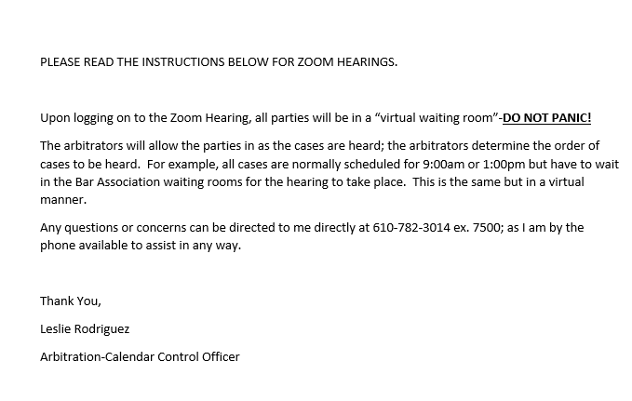

Presentation of Evidence
Pennsylvania Rule of Civil Procedure 1305 requires that the Pennsylvania Rules of Evidence be followed in any arbitration hearing.

Certain documents "shall be admitted into evidence" without the need to authenticate the documents. This list includes:
- Bills or other documents evidencing charges incurred;
  - The board of arbitrators may find a bill authentic, necessary and reasonable without extrinsic evidence but is not required to do so.

- Records of businesses, government departments, agencies or offices, subject to statutory restrictions, provided that these are records which would otherwise be admissible if authenticated by a custodian of records;

- Records and reports of hospitals and licensed health care providers;

- Expert reports and descriptions of expert qualifications;

- Written estimates of value, damage to, cost of repair of or loss of property; and
  - Written estimates "shall be accompanied by a statement of the party offering it whether the property was repaired and, if it was, whether the repairs were made in full or in part and by whom, together with a bill therefor."

- Reports of rate of earnings and time lost from work or lost compensation prepared by an employer.

These documents are required to be admitted without the need for authentication only "if at least twenty days' notice of the intention to offer them was given to every other party accompanied by a copy of each document to be offered. "
Where a party did not give twenty days' advance notice of the intent to enter the documents but "copies of the documents were provided to the other parties at least twenty days in advance of the hearing or during discovery, the admissibility of the documents without authentication shall be in the discretion of the arbitrators upon a finding of the absence of prejudice."

Any document admitted under Rule 1305(b)(l) is only able to be used for "those purposes which would be permissible if the person whose testimony is waived by this rule were present and testify at a hearing."

If a document contains information which would be inadmissible through a live witness offering the same testimony, such as hearsay not subject to an appropriate exception, "[t]he arbitrators shall disregard any [such] portion of the document so received.”
Even if a party presents a document in lieu of a witness' appearance through Rule 1305(b)(l), "Any other party may subpoena the person whose testimony is waived by this rule to appear at or serve upon a party a notice to attend the hearing and any adverse party may cross-examine the person as to the document as if the person were a witness for the party offering the document. The party issuing the subpoena shall pay the reasonable fees and costs of the person subpoenaed to testify, including a reasonable expert witness fee if applicable."

Certain documents are admissible without any certifications. These include:
- An official weather report;
- An official traffic signal report;
- A standard United States Government life expectancy table;
- "Any other official record kept within the Commonwealth."

Practice Tips for Arbitration Hearings
Before Arbitration:
- Exhibits should be labeled and organized;
- Bring enough copies of exhibits for the panel, opposing counsel, and yourself. You may leave the exhibits with the tipstaff for shredding upon completion;
- When possible, work with opposing counsel to stipulate out insignificant issues in order to keep the focus on the crux of the dispute;
- Consider preparing an Arbitration Memorandum where there are more complex facts and legal disputes;
- Ensure that you comply with Rules 1305 regarding the provision of twenty days’ notice for admission of permissible exhibits;
- Prepare witnesses for their testimony;
- Verify the docket reflects service where applicable;
- Prepare for your cases in a timely fashion to avoid last minute requests to the court;
- Communication is key! Always keep in communication with the court and other parties for any changes and/or questions/concerns.
Case Presentation:
- Appear on time. Call if you or any party to the case will be arriving late.
- Do not hand the arbitration panel exhibits without guidance or labeling;
- Have all of the case information readily available;
- Be coherent in presenting your case. Prepare as if you will be presenting in a jury trial;
- Keep focused on the more relevant aspects of the case;
- If the case will be taking longer than two hours to present you must notify court administration as soon as possible.

Online Access During Arbitration Hearings

The Lehigh County Bar Association provides internet access in the building.

Online access is provided as a guest of the facilities, please use appropriately.

The arbitrators have access to laptops with the needed online access to complete the hearings. Please do not use the laptops to do any other internet search, as the computers do slow down and start acting up when that is done.

Any questions regarding docket accessibility for parties need to be addressed with the Clerk of Judicial Records – Civil Division at 610-782-3148.

SERVING ON A PANEL
Expectations of Service:
If you would like to serve on a panel, the following is required;
- An e-mail expressing the desire to be assigned as an arbitrator to CAhelp@lehighcounty.org.
- You will receive an e-mail from the Arbitration Coordinator with an Arbitrator Application Form.
- Once the Arbitrator Application Form is received, it will be forwarded to Judge Thomas M. Caffrey for review and be placed on a waiting list.
- When an opening becomes available, you will be assigned to a panel.

Arbitrators are expected to be professional and courteous at all times, during all aspects of the arbitration process.

The following is a guideline:
- Please arrive no later than 8:45 AM.
- If you cannot complete your assigned date, you are responsible for finding a substitute and contacting the Arbitration Coordinator no less than five days prior, unless it is an emergency.
- If you do not participate in any assigned dates in a yearly cycle, you will be removed from the panel.
- Make sure to check in and out with the tipstaff. No one should be leaving without receiving confirmation that all hearings have been completed.
- All cellphones must be silenced during arbitration hearings.
- The number of hearings scheduled fluctuates. The tipstaff do not know how many cases will be presented.
- Make sure that the Arbitration Coordinator has current contact information for you.
- If you wish to resign from a panel, you must e-mail a letter to CAhelp@lehighcounty.org for the request to be processed.
- Professional Court attire and grooming are required for all parties representing the court.

Inability to serve on assigned date:

If an arbitrator cannot appear on an assigned date, it is their responsibility to contact the substitutes (or alternates) in their panel first to see if they can assist.
If no one can assist, you must contact the Arbitration Coordinator for assistance. The Arbitration Coordinator will provide a list of names and telephone numbers to contact to find a substitute.
Once a substitute is found, you must contact the Arbitration Coordinator to provide the information.

Recusal of an arbitrator

“An arbitrator [takes] on the role of judge in determining the merits of a case and upon motion the arbitrator is the one to initially determine if a recusal request has merit” Sheehan v Nationwide Insurance Co., 779 A.2d 582, 585 (Pa. Super. 2001).

Where a party seeks to challenge an arbitrator’s refusal to recuse him or herself, the party “must establish substantial doubt about the arbitrator’s ability to act impartially.” Id. That party bears the burden of producing “evidence establishing bias, prejudice or unfairness which raises a substantial doubt as to the jurist’s ability to preside impartially.” Id. (citing Commonwealth v. White, 734 A.2d 374 (Pa. 1999).

“Arbitrator who was an associate in a firm 23 years prior to arbitration and had contact with one of the parties in his capacity as an associate not required to recuse himself.” Sheehan, 779 A.2d at 58.

“Ongoing and undisclosed attorney-client relationship with insured rendered arbitrator unfit to serve on arbitration panel where client was a litigant due to fiduciary duty of loyalty owed to client” Donegal Insurance Co. v. Longo, 610 A.2d 466 (Pa Super. 1992).

Notify the Arbitration Coordinator if there are any conflicts as an arbitrator. If an arbitrator works in a firm that represented a party in a prior matter and it is a large firm, that doesn’t necessarily recuse the arbitrator from the case unless they were directly involved in some way. It is the responsibility of the arbitrator to remain impartial and notify the court if they feel they cannot do so.

APPENDIX
Login information for online docket access
Attorneys can obtain free access through lehighcounty.org. (website path for attorneys: lehighcounty.org > Services > Attorney Docket Access > Create New Account)
The request is sent to the Clerk of Judicial Records – Civil Division for approval.
Pro Se litigants can receive access as well, however there is a yearly fee that must be paid before login information is created. Pro Se litigants can contact fiscal to find out how much the fee is. Fiscal will contact the pro se party about payment and next steps. (website path for pro se litigants: lehighcounty.org> Services> Online Records Access).
Through Public Access and Attorney Docket Access, all hearings, past and future, are viewable.
Public Access is utilized for Civil, Orphan’s Court, Family Court and Register of Wills.
The docket summary will contain blue hyperlinks to view the filed documents.

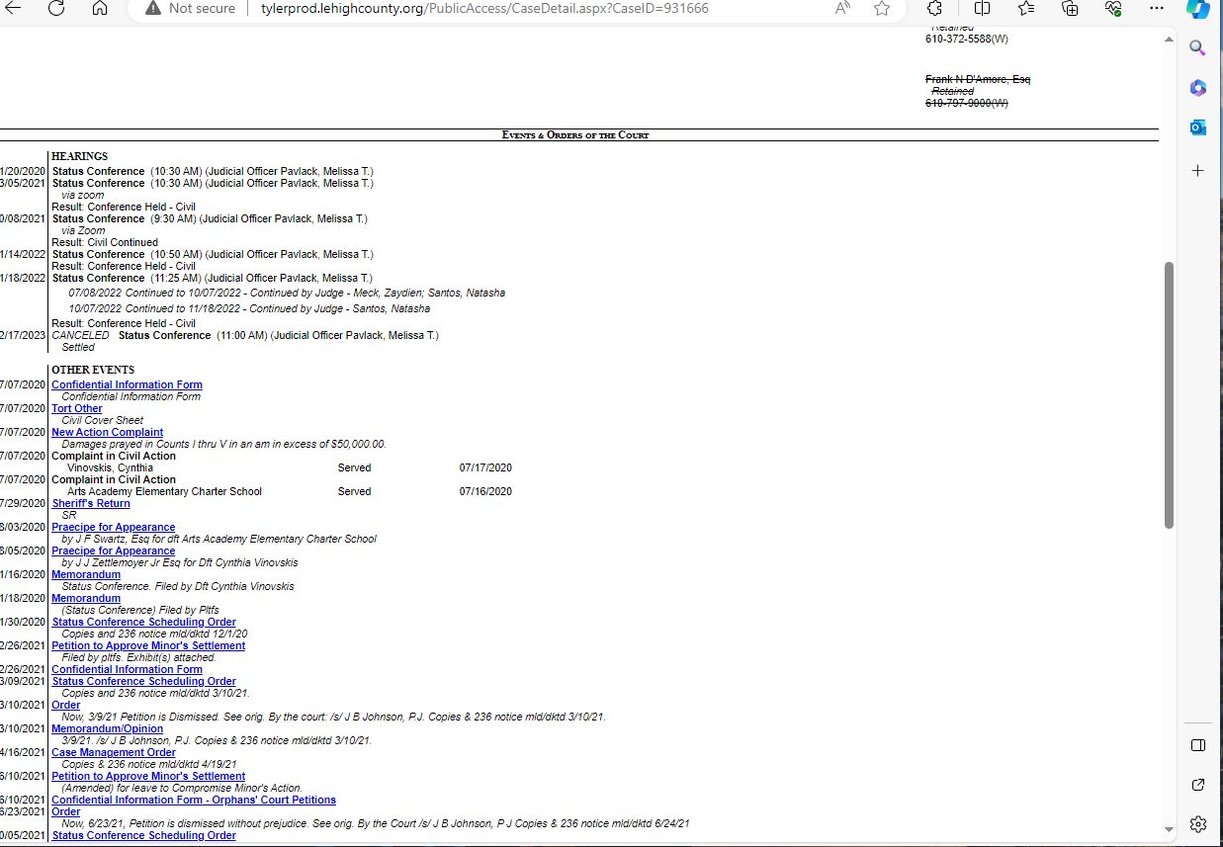
Lehigh County Rules of Civil Procedure
Rule 1301 – Compulsory Arbitration – Scope
    - All civil actions which are subject to compulsory arbitration under the Judicial Code, in which the amount in controversy, exclusive of interest and costs, is Fifty Thousand ($50,000.00) Dollars or less, shall be submitted to compulsory arbitration.
    - The amount in controversy shall be the largest amount claimed in any single count of the pleadings.
    - The court, upon the written motion of any party, or upon its own motion, may require that a case for which a trial is demanded be first submitted to compulsory arbitration pursuant to these rules.
Rule 1302 – Compulsory Arbitration – Arbitrators
- A list of available arbitrators shall be prepared by the Court Administrator. The list shall consist of a sufficient number of members of the bar of Lehigh County who express a willingness to serve and who are actively engaged in the practice of law primarily in Lehigh County in accordance with Pa.R.C.P. 1302(a).
- Each attorney who satisfies the requirements of Rule 1302(a) may submit his or her name to the court administrator who shall, with the approval of the administrative judge-civil division, assign said attorneys to various permanent arbitration panels. The composition of the panels may be changed from time to time as may be deemed appropriate by the court administrator, with the approval of the administrative judge-civil division.
- Each panel so comprised shall consist of five (5) attorneys, three (3) of whom shall be the assigned arbitrators, and two (2) of whom shall be substitutes. The chairperson of each panel shall have been actively engaged in the practice of law in this court for at least three (3) years. Should a substitution of an assigned arbitrator be necessary, he or she shall arrange for one of the two substitutes to be present at the arbitration. Should neither of the two substitutes of the panel be able to sit, the assigned arbitrator may arrange for a substitute from a list of court-approved permanent substitute arbitrators. A panel member who cannot sit and who has made the proper arrangements for a substitute shall notify, in writing, the other panel members and counsel for all parties or the parties themselves if unrepresented by counsel. In addition, a copy of this writing shall be mailed to the court administrator.
- Each arbitrator will be compensated such rate as may be set by the court from time to time by administrative order.
Rule 1302.1 – List of Arbitrators
- The court administrator shall prepare and maintain a permanent roster of available arbitrators which shall be designated "List of Arbitrators" and shall contain the names of all attorneys who have met the qualifications set forth in Leh. R.C.P. 1302(a), supra, together with the date of admission to the bar of this court.
- An attorney whose name is contained on the list of arbitrators may resign by letter addressed to the court administrator, whereupon the court administrator shall note the resignation and date thereof on the appropriate list or lists behind the attorney's name
Rule 1302.3 – Composition of Board of Arbitrators
- Each board of arbitrators is composed of one chairperson and two attorneys from the list of arbitrators.
- Substitutions are made from the appropriate list or lists by the court administrator.
- Appointments to boards of arbitrators is made by the court administrator.
- If an appointed arbitrator cannot serve at the time and place designated, the attorney shall, unless prevented by matters beyond his or her control, notify the court administrator at least five (5) days in advance of the date upon which the hearing has been scheduled. That attorney shall then be appointed an arbitrator at the first opportunity thereafter. If any arbitrator fails to give notice as aforesaid or simply fails to appear at a scheduled arbitration, his or her name shall be passed over and that attorney shall not receive another appointment until his or her name reappears for appointment in due course. If any arbitrator is guilty of such a failing a second time, the attorney's name shall be removed from the appropriate list or lists and he or she shall not thereafter serve as an arbitrator until reinstated upon application to the court.
Rule 1302.4 – Notification of Appointment of Arbitrators
- The court administrator shall mail a copy of the appointment of a board of arbitrators to each arbitrator appointed, each attorney of record and in the event a party is not represented by an attorney to such party at his last known address by regular mail and file of record proof of such notice.
Rule 1302.5 – Compensation of Arbitrators
- For the first hearing, the arbitrators shall receive compensation as set by administrative order of this court.
- Where more than one hearing becomes necessary, additional compensation may be allowed at the discretion of the court upon petition and cause shown by the chairperson on behalf of all of the members of the board. Such a petition shall be presented to the administrative judge of the civil division of the court.
- No compensation shall be allowed when settlement occurs prior to the hearing, when counsel and the arbitrators report for a hearing and a settlement is announced or when no testimony is received at the hearing. In such cases, however, that panel of arbitrators shall be assigned another case at the first opportunity.
Rule 1303 – Hearing
- Arbitrations will be held on the date and at the time and place prescribed by the court administrator.
- The Clerk of Judicial Records—Civil Division shall notify all attorneys of record of the date, time and place of the hearing by email addressed to the attorneys' email address of record. If a party is not represented by counsel of record, that party shall be given notice by email addressed to the party's email address of record. The Clerk of Judicial Records—Civil Division shall file of record proof of such notice.
- Notice shall be given to the parties or their attorneys of record at least thirty (30) days prior to the scheduled arbitration. The Court Administrator shall, by email addressed to the email address on file with the Court Administrator, notify all arbitrators assigned to an arbitration panel of the dates on which the arbitration panel is assigned to hear arbitration cases and the location of the arbitration hearings. In addition, prior to the scheduled arbitration date, the Court Administrator shall, by said email, send all of the arbitrators assigned to the arbitration panel a list containing the names of the cases to be heard, the names of the parties and the names of all counsel for the parties. In the event any of the arbitrators believes that he/she has a conflict of interest in connection with hearing any particular case, the arbitrator shall immediately notify the Court Administrator in writing that the arbitrator believes there is a conflict of interest and the reasons therefore, with a copy to all counsel or unrepresented parties involved in the particular case.
- On the date of the arbitration hearing, all counsel should check in with the representative of the court administrator’s office located at the site of the arbitration. Cases in which all parties have checked in and have indicated they are ready to proceed will be assigned to a panel for hearing, by the representative of the court administrator’s office after consultation with the panel chairman. All cases on the list are intended to be reached, and all counsel should be prepared to commence their case at the time they are directed to report for the arbitration.
- In the event that the panels of arbitrators are unable to reach all of the cases scheduled for arbitration on a particular day, the arbitration hearing for those cases that are not reached shall be continued by the court administrator’s office to the morning of the next available date for arbitrations generally. In the event that an arbitration hearing has been commenced but is not concluded on the day scheduled for the arbitration hearing, the arbitration hearing shall be continued to the morning of the next available date that the same members of the arbitration panel which commenced hearing the case are scheduled and available to hear arbitration cases.
- The written notice provided for above shall include the following statement: “This matter will be heard by a board of arbitrators at the time, date and place specified but, if one or more of the parties is not present at the hearing, the matter may be heard at the same time and date before a judge of the court without the absent party or parties. There is no right to a trial de novo on appeal from a decision entered by a judge.”
Rule 1303.1 – Continuances
- Any application for a continuance of a scheduled arbitration hearing shall be presented on the approved continuance request form to the administrative judge, civil division, or his designee, at least five (5) days prior to the arbitration date. The continuance request must be on a form approved by the court, and shall contain all of the reasons for the request for continuance. Amplification of reasons, by letter or in person, will not be considered by the court. The application for continuance will not be considered unless it contains the position of opposing counsel, either by signature of the opposing counsel or by verification of the counsel presenting the request for continuance. Good cause shall be required for continuance of an arbitration hearing. The filing of a pre-trial motion after a case has been scheduled for arbitration will not result in an automatic continuance of the arbitration hearing.
- If the application for continuance of a scheduled arbitration hearing is granted, the court administrator shall select and set a date certain for the arbitration hearing to be held. Counsel may select a date certain for the continuance of the arbitration hearing from a list of available dates provided by the court administrator’s office, provided that all counsel agree to said date. A selection of a date certain certifies to the court that the date has been cleared with opposing counsel and the court administrator. Continuances will not be granted from a date certain selected by counsel.
- If an application for continuance is not made at least five (5) days prior to the arbitration hearing, then a continuance shall only be granted by the court for good cause which was not apparent five (5) days prior to the date set for the arbitration hearing.
Rule 1303.2 – Scheduling of Arbitration Hearing: Notice
- A matter subject to compulsory arbitration shall be listed for hearing by (1) praecipe of any party when the pleadings are closed or the time for filing pleadings has ended, and there are not any outstanding motions requiring disposition by the court, or by (2) the court administrator under circumstances hereafter described.
- By Praecipe of Any: Party A party may, following compliance with the discovery notice herein required, request that a matter be scheduled for arbitration by using forms provided by the clerk of courts, civil division for such purpose.
- A party shall not praecipe a case for arbitration until the party has served upon opposing counsel and any unrepresented parties a notice of intent to request arbitration. Within twenty (20) days after the date of the notice, a party desiring any additional discovery shall notify other counsel and unrepresented parties of the scope and nature of such additional discovery. Discovery must be completed within 120 days from the giving of notice to pursue additional discovery.
- If no discovery request is sent within twenty (20) days after the date of the notice of intent to arbitrate, a party may praecipe the case for arbitration by filing same with clerk of courts.
- If a discovery request is made, a party may praecipe the case for arbitration upon completion of discovery or the expiration of 120 days from the giving of the notice to pursue discovery, whichever comes first, unless the time for discovery is extended by the court.
- A party shall not be required to serve notice of intent to request arbitration if the matter has been pending for a period one (1) year or more.
- Notwithstanding the foregoing, discovery in cases involving district justice appeals shall be completed within sixty (60) days from the filing of the appeal.
- As Set by the Court Administrator: The court administrator may schedule matters for arbitration under the following circumstances:
- All matters that are appeals from a district justice decision may be scheduled for arbitration hearing sixty (60) days after the appeal is taken, unless there are outstanding pleadings, motions, petitions, or other matters that require court disposition. The parties to a district justice appeal shall file pleadings and complete discovery within sixty (60) days of the date of the appeal.
- All other matters which are subject to compulsory arbitration may be scheduled for arbitration hearing no later than one (1) year after the commencement of the action, unless there are outstanding motions, petitions, or other matters that require court disposition. The parties to an action which is subject to compulsory arbitration shall file all pleadings and complete all discovery within six (6) months of the date of the commencement of the action, unless the time for completion of discovery has been extended by the court upon motion of any party.
- In the event one or more parties do not appear for the scheduled arbitration, the remaining parties may consent to having the judge assigned to monitor the case hear the matter on the same date as the scheduled arbitration hearing. It shall be discretionary with the judge whether to hear the case as requested.
- The filing of dispositive motions within thirty (30) days of the scheduled arbitration hearing shall not be grounds for continuance of the hearing unless good cause is shown.
Rule 1304 – Conduct of Hearing, General
- The board of arbitrators shall have no power to allow amendment of pleadings, allow the addition or substitution of parties or rule on preliminary objections, motions for judgment on the pleadings or motions for summary judgment.
- Procedural rules described in Pa. R.C.P. 1304 shall apply to the conduct of arbitration hearings.
- Parties may present agreements on awards to be entered by the arbitrators orally on the date of hearing, or in writing prior thereto.
- If it appears at the arbitration hearing that any defendant has not been properly served, judgment shall be entered for that defendant.
- If it appears at the arbitration hearing that a complaint has not been filed, judgment shall be entered for the defendant.
- If it appears at the arbitration hearing that a defendant has appealed a district justice judgment, and has not served a rule to file a complaint upon the plaintiff, an award shall be entered in favor of the plaintiff.
Rule 1305 – Conduct of Hearing, Evidence
- Initially all rulings on objections to evidence or on other issues which arise during the hearing shall be made by the chairperson of the board of arbitrators, and such rulings shall be final unless one of the other arbitrators disagrees with the same. In the latter instance, the arbitrators shall consult and vote, and the final ruling shall be that of the majority.
- Following the hearing, the chairperson of the board of arbitration may release to the respective parties the exhibits introduced.
- Evidentiary rules described in Pa.R.C.P. 1305 shall apply to the conduct of arbitration hearings.
Rule 1306 – Award – Delay Damages
- Arbitrators may consider the subject of damages for delay pursuant to Pa.R.C.P. 238 after a decision had been reached on the merits and has been entered on the award form.
- After the amount of the award has been so entered, the board shall make a determination as to damages for delay in accordance with Pa.R.C.P. 238 by accepting a sealed envelope containing a stipulation setting forth whether an offer was made in writing and if so, the amount as well as the date of the offer.
- If damages for delay under Pa.R.C.P. 238 are awarded, the amount thereof shall be added to the principal amount awarded, but shall be separately stated on the award.
Rule 1307 – Costs
- Witness fees and costs shall conform to fees and costs pertaining to civil actions in the Court of Common Pleas of Lehigh County.
Rule 1309 – Appeals from Arbitration
- All appeals compulsory arbitration must be timely filed with the Clerk of Judicial Records—Civil Division accompanied by payment in the amount of $750.00 or 50% of the amount in controversy, whichever is less. Appellant shall contemporaneously provide a copy of the appeal to the Court Administrator's office.

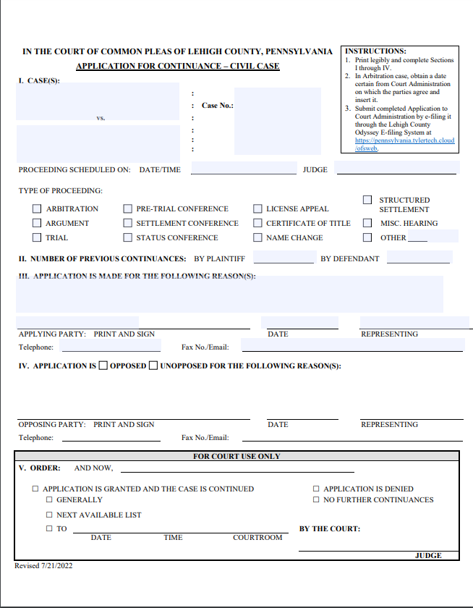

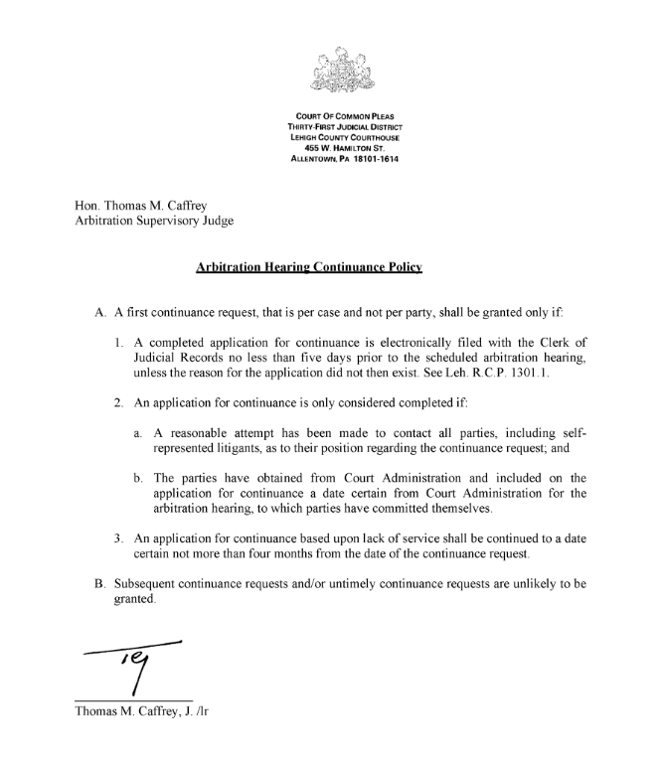
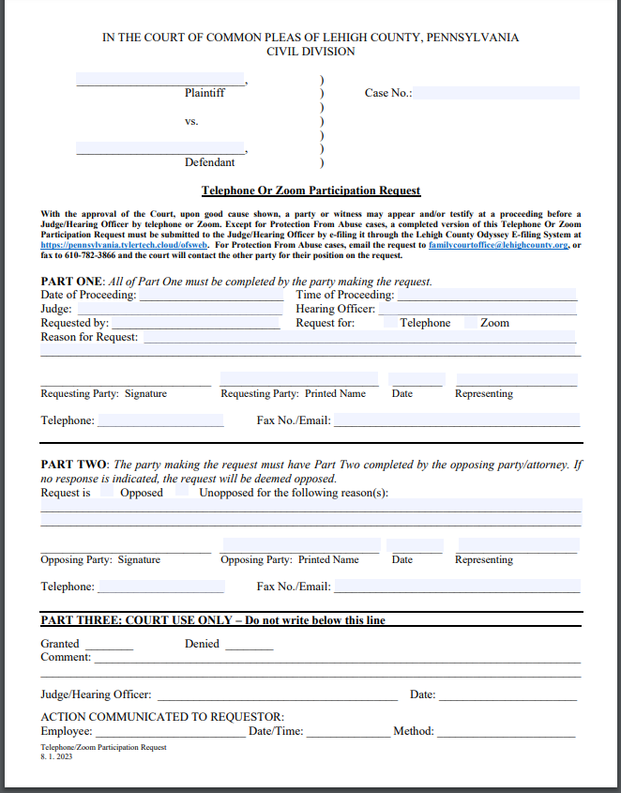

Leh. R.C.P. 1301(a)(b)(c)
Leh. R.C.P. 1303.2(3)(i)
Leh. R.C.P. 1301 (Comment)
Pa.R.C.P. 1305(a).
Id. 1305(c).
Id. 1305(b)(l).
Id 1305(b)(2).
Id 1305(b)(4).
Id 1305(d).

